Village of Algonquin
Village of Cary
City of McHenry
City of Woodstock
MCHENRY COUNTY AREA PAVEMENT MANAGEMENT TASK FORCE
SOLICITING AGENCY: VILLAGE OF CARY
2016 CRACK FILLING PROGRAM
REQUEST FOR JOINT BID
2016
LEGAL NOTICE / PUBLIC NOTICE
VILLAGE OF CARY
JOINT BID NOTICE

The Village of Cary, Village of Algonquin, City of McHenry, and City of Woodstock are jointly soliciting sealed bids from construction contractors for the following project:

2016 Crack Filling Program
Joint Bid

Sealed bids for this contract must be received before 11:00 a.m. on Friday, May 20, 2016 at the Cary Village Hall, 655 Village Hall Drive, Cary, Illinois 60013, at which time all bids will be publicly opened and read aloud.

The scope of the work includes routing of asphalt pavement cracks, cleaning of routed cracks, provision of crack sealant compound, and installation of the compound with routed and cleaned cracks, to be performed throughout the Municipalities.

Copies of the bidding documents, including contract provisions and specifications, may be obtained at the Village of Cary Public Works Department by calling Engineering Technician Scott Fish at 847-639-0003 or emailing a request to CaryPW@CaryIllinois.com. It is the responsibility of the bidder to meet all requirements of the bid documents. All work under this contract shall comply with the Prevailing Wage Act of the State of Illinois, 820 ILCS 130/0.01 et seq. & the Employment of Illinois Workers on Public Works Act (30 ILCS 570/0.01 et. seq).

All bids shall be accompanied by a Bid Bond, Certified or Cashier’s Check made payable to the Village of Cary for not less than ten percent (10%) of the bid amount. The successful bidder must furnish a satisfactory performance and payment bond in the full amount of the bid.

The Municipalities reserve the right to accept the bid from the lowest responsible bidder most favorable to the Municipalities, as determined by the Municipalities. The Municipalities also reserve the right to reject any bid or part of a bid that does not conform to the bidding requirements or to modify or waive all formalities and technicalities in a bid, or to reject all bids.

Compliance conditions are included in the bid documents.

Dated: May 6, 2016
Erik D. Morimoto, PE, PTOE
Director of Public Works / Village Engineer

MCHENRY COUNTY AREA
PAVEMENT MANAGEMENT TASK FORCE
2016 CRACK FILLING PROGRAM JOINT BID

OWNER CONTACT INFORMATION

Village of Cary (Soliciting Agency)
454 Cary Woods Circle
Cary, Illinois 60013
Telephone: 847-639-0003
Attention: Erik Morimoto
Director of Public Works / Village Engineer

Village of Algonquin
110 Meyer Drive
Algonquin, IL 60102
Telephone: 847-658-2754
Attention: Bob Mitchard
Director of Public Works

City of McHenry
1415 Industrial Drive
McHenry, IL 60050
Telephone: 815-363-2186
Attention: Jon Schmitt
Director of Public Works

City of Woodstock
326 Washington Street
Woodstock, Illinois 60098
Telephone: 815-338-6118
Attention: Jeff Van Landuyt
Director of Public Works

MCHENRY COUNTY AREA
PAVEMENT MANAGEMENT TASK FORCE
2016 CRACK FILLING PROGRAM JOINT BID

INVITATION FOR BIDDER’S PROPOSALS

As part of the McHenry County Area Pavement Management Task Force, the Village of Cary is organizing a joint bid on behalf of various municipalities for the 2016 Crack Filling Program. Each municipality will award the bid and use its own contract documents to execute the work with the successful bidder.

1. Invitation to Bid

Owner invites sealed Bidder's Proposals for the Work described in detail in the Contract and generally described as follows:
Routing of asphalt pavement cracks, cleaning of routed cracks, provision of crack sealant compound, and installation of the compound with routed and cleaned cracks.
The work shall be performed at the following Work Sites in the:

- Village of Algonquin, Illinois
- Village of Cary, Illinois
- City of McHenry, Illinois
- City of Woodstock, Illinois

2. Defined Terms

All terms capitalized in this Invitation for Bidder's Proposals and in the other documents included in the Bid Package are defined in the documents included in the Bid Package, as hereinafter defined, and shall have such defined meanings wherever used.

3. The Bid Package

The Bid Package consists of the following documents, all of which are by this reference made a part of this Invitation for Bidder's Proposals as though fully set forth herein:

- Invitation for Bidder's Proposals;
- General Instructions to Bidders;
- Addenda, if issued;
- Bidder's Proposal;
- Bidder's Sworn Acknowledgment;
- Bidder's Sworn Work History Statement;
- Other Information Submitted by Bidder, if requested;

4. Inspection and Examination

The Bid Package may be examined at the Village of Cary Village Hall (655 Village Hall Drive, Cary, IL 60013). A copy of the Bid Package may also be received upon request by calling the Village of Cary Public Works Department at 847-639-0003 or emailing CaryPW@CaryIllinois.com.

Each prospective Bidder shall, before submitting its Bidder's Proposal, carefully examine the Bid Package. Each prospective Bidder shall inspect in detail the Work Site and the surrounding area and shall familiarize itself with all local conditions, including subsurface, underground and other concealed conditions, affecting the Contract, the Work and the Work Site. The Bidder whose Bidder's Proposal is accepted will be responsible for all errors in its Bidder's Proposal including those resulting from its failure or neglect to make a thorough examination and investigation of the Bid Package and the conditions of the Work Site and the surrounding area.

5. Bid Opening

Owner will receive sealed Bidder's Proposals for the Work until 11:00 A.M., local time, MAY 20, 2016 at the Village of Cary Village Hall, 655 Village Hall Drive, Cary, IL 60013, at which time, or as soon thereafter as possible, all Bidder's Proposals will be publicly opened and read aloud. Bidders or their agents are invited to be present.

MCHENRY COUNTY AREA
PAVEMENT MANAGEMENT TASK FORCE
2016 CRACK FILLING PROGRAM JOINT BID

GENERAL INSTRUCTIONS TO BIDDERS

- Interpretation of Documents Included in Bid Package

- Defined Terms. All terms capitalized in these General Instructions to Bidders and in the other documents included in the Bid Package are defined in the documents included in the Bid Package and shall have such defined meanings wherever used.

- Implied Terms. If any personnel, equipment, materials, or supplies that are not directly or indirectly set forth in the Contract are nevertheless necessary to the proper provision, performance, and completion of the whole of the Work in accordance with the intent of the Contract, each prospective Bidder shall understand such personnel, equipment, materials, or supplies to be implied and shall provide for such personnel, equipment, materials, or supplies in its Bidder's Proposal as fully as if it were particularly described.

- Information Provided by Owner. When information pertaining to subsurface, underground or other concealed conditions, soils analysis, borings, test pits, utility locations or conditions, buried structures, condition of existing structures, and other preliminary investigations is distributed with the Bid Package, or such information is otherwise made available to any prospective Bidder by Owner, such information is distributed or made available solely for the convenience of such prospective Bidder and is not part of the Bid Package. Owner assumes no responsibility whatever in respect to the sufficiency or accuracy of any such information, and there is no guaranty or warranty, either expressed or implied, that the conditions indicated are representative of those existing throughout the Work or the Work Site, or that the conditions indicated are representative of those existing at any particular location, or that unanticipated conditions may not be present. Any information furnished by the Municipality shall not constitute a representation concerning site conditions and the Contractor shall bear, solely and exclusively, all costs due to concealed, unknown, unusual or otherwise unforeseen conditions at the site. Contractor is aware that all such risk concerning site conditions is borne by it, has considered such in making its bid, and therefore freely waives all of its rights under the Illinois Public Construction Contract Act of 1999.

- Addenda. No interpretation of the documents included within the Bid Package will be made except by written addendum duly issued by Owner (“Addendum”). No interpretation not contained in an Addendum shall be valid or have any force or effect whatever, nor entitle any Bidder to assert any claim or demand against Owner on account thereof.

All Addenda issued prior to the opening of Bidder's Proposals shall become a part of the Bid Package. Each prospective Bidder shall be responsible for inquiring from time to time as to the availability of Addenda.

If any prospective Bidder is in doubt as to the true meaning of any part of the Bid Package, such prospective Bidder shall submit to Owner a written request for an interpretation thereof as far in advance of the scheduled opening of Bidder's Proposals as possible.

Owner shall use its best efforts to issue Addenda in response to all valid, appropriate, and timely inquiries, but accepts no responsibility for doing so. Inquiries not answered by Addenda shall be considered invalid, inappropriate, or untimely inquiries.

- Informal Responses. Neither Owner nor Engineer will give oral answers or instructions in response to any inquiries received prior to the award of the Contract regarding the meaning of the Bidding Documents or the Contract nor any oral indication as to the validity of any such inquiry. Any such oral answer, instruction or indication shall not be binding, shall be deemed to be unauthorized and given informally for the convenience of the Person making the inquiry, shall not be guaranteed, and shall not be relied upon by any prospective Bidder. By submitting a Bidder’s Proposal, each Bidder shall be deemed to have agreed that such information has not been used as a basis of its Bidder’s Proposal and that the giving of any such information does not entitle such Bidder to assert any claim or demand against Owner or Engineer on account thereof.

2. Calculation of Unit Price Proposals

On all items for which Bidder's Proposals are to be received on a unit price basis, the approximate quantities stated in the Schedule of Prices are Owner's estimate only for Owner's convenience in comparing Bidder's Proposals and shall not be relied upon by prospective Bidders. Each prospective Bidder shall, before submitting its Bidder's Proposal, make its own estimate of the quantities of Unit Price Items required to complete the Work and shall determine its Price Proposal for each Unit Price Item in light of its own estimate.

3. Term

The term of this Agreement shall be for one (1) year from the date of award. The Municipalities, as a whole, reserve the right to renew this contract for two (2) additional one (1) year periods, subject to acceptable performance by the Contractor. At the end of the initial or renewal term, the Municipalities, as a whole, reserve the right to extend this agreement for a period of up to ninety (90) days for the purpose of getting a new agreement in place.
For any term beyond the initial term, this agreement is contingent on the appropriation of sufficient funds; no charges shall be assessed for failure of the Municipalities to appropriate funds in future contract years.

4. Prevailing Wages

To the extent that the Prevailing Wage Act (820 ILCS 130/0.01 et seq.) (Act) applies to this Contract, it is the Contractor's obligation to pay (and require every Subcontractor to pay) prevailing wages as established by the Illinois Department of Labor for each craft or type of work needed to execute the Contract in accordance with the Act. The established prevailing wage rates are available at www.state.il.us/agency/idol/rates/rates.HTM. If the contractor determines the Prevailing Wage Act is applicable to a project, they shall post or provide notice of the prevailing wage rates in accordance with the Act. Any increases in costs to the Contractor due to changes in the prevailing rate of wages during the terms of this Contract shall be at the expense of the Contractor and not at the expense of the Owner. Any change order shall be computed using the prevailing wage rates applicable at the time the change order work is scheduled to be performed. The Contractor shall be solely responsible to maintain and file accurate records in the manner set forth in, and as required by the Act. The Contractor shall be solely liable for any violation of the Act and shall be required to (i) pay the difference between prevailing wages and any wages actually received by laborers, workmen and/or mechanics engaged in the Work and (ii) defend and indemnify the Owner against any and all claims arising under or related to the Act, including any damages, attorneys’ fees, and penalties or fines.

5. Taxes and Benefits

Owner is exempt from state and local sales, use, and excise taxes. Bidder's Price Proposal shall not include any such taxes. A letter of exemption will be provided to the successful Bidder, if necessary. Owner will not reimburse, nor assist the successful Bidder in obtaining reimbursement for, any state or local sales, use or excise taxes paid by the successful Bidder.

Bidder's Price Proposal shall include all other applicable federal, state, and local taxes of every kind or nature applicable to the Work as well as all taxes, contributions, and premiums for unemployment insurance, old age or retirement benefits, pensions, annuities or other similar benefits.

6. Permits and Licenses

Except as otherwise expressly provided in Attachment A to the Contract, Bidder's Price Proposal shall include the cost of obtaining all permits, licenses, and other approvals and authorizations required by law for performance of the Work. It shall be the sole responsibility of each prospective Bidder to determine the applicable permits, licenses, and other approvals and authorizations and no extra compensation shall be paid by Owner for the successful Bidder's failure to include these costs in its Bidder's Proposal.

7. Preparation of Bidder's Proposal

Bidder's Proposals to enter into the Contract for the Work shall be made only on the blank Bidder's Proposal form furnished by Owner and included in the Bid Package. The Bidder's Proposal form included in the Bid Package shall be removed from the Bid Package prior to preparation for submission.

Entries on the Bidder's Proposal form shall be typed or legibly written in ink. Price Proposals are to be written by words and by figures as provided on the Bidder's Proposal form. In case of any conflict, words shall prevail. In case of any error in adding or multiplying individual items, the prices listed for individual items shall control over any incorrect total of such items. A Bidder's Proposal may be rejected if it does not contain a requested price for each and every item named in the Bidder's Proposal form or may be interpreted as bidding “no charge” to Owner for any item left blank.

Prospective Bidders are warned against making alterations of any kind to the Bidder's Proposal form or to any entry thereon. Bidder's Proposals that contain omissions, conditions, alterations, or additions not called for may be rejected or interpreted so as to be most favorable to Owner.

Each Bidder shall securely staple into its Bidder's Proposal a copy of each Addendum issued and shall include in the place provided therefore in the Bidder's Proposal form a listing of all such Addenda.

Each Bidder shall complete and securely staple into its Bidder's Proposal the Bidder's Sworn Acknowledgement and the Bidder's Sworn Work History Statement included in the Bid Package, and shall staple into its Bidder's Proposal the Bid Security and the surety and insurance commitment letters.

Every Bidder submitting a Bidder's Proposal shall be conclusively deemed to have evidenced an intention to be bound thereby whether or not the requirements for signing Bidder's Proposals found in Section 7 of these General Instructions to Bidders are satisfied. However, any Bidder's Proposal that fails to comply with Section 7 of these General Instructions to Bidders may nevertheless be rejected.

Bidder's Proposals that are not submitted on the Bidder's Proposal form furnished by Owner or that are not prepared in accordance with these General Instructions to Bidders may be rejected. If a deficiently prepared Bidder's Proposal is not rejected, Owner may demand correction of any deficiency and award the Contract to Bidder upon satisfactory compliance with these General Instructions to Bidders.

8. Signature Requirements

- Bidder's Proposals. The following requirements shall be observed in the signing of each Bidder's Proposal:

- Corporations. Each Bidder's Proposal submitted by a corporation shall be signed by the President or other authorized officer of the corporation and shall also bear the attesting signature of the Secretary or Assistant Secretary of the corporation.

- Partnerships. Each Bidder's Proposal submitted by a partnership shall be signed by all of its general partners or by an attorney-infact.

- Individuals. Each Bidder's Proposal submitted by an individual shall be signed by such individual or by an attorney-in-fact.

- Joint Ventures. Each Bidder's Proposal submitted by a joint venture shall be signed by each signatory of the joint venture agreement by which such joint venture was formed in accordance with the applicable provisions of (1), (2), and (3) above or by an attorney-in-fact.

When requested by Owner, satisfactory evidence of the authority of the person or persons signing on behalf of Bidder shall be furnished.

- Other Documents. The signature requirements set forth in Subsection 7A shall apply to all other documents in the Bid Package required to be executed by Bidder, Bidder's sureties and Bidder's insurance representatives as well as to the Contract, the Contractor's Certification, and all other required documentation related to the Contract.

9. Bid Security, Performance Bonds, and Insurance

- Required Bid Security. Every Bidder's Proposal shall be accompanied by bid security in the form of a:
    - Cashier's Check; or
    - Certified Check drawn on a solvent bank insured by the Federal Deposit Insurance Corporation and payable without condition to Owner; or
    - Bid Bond in a form satisfactory to Owner from a surety company licensed to do business in the State of Illinois with a general rating of A-minus and a financial size category of Class X or better in Best's Insurance Guide.
The Bid Security shall stand as a guaranty that (1) Bidder will submit all additional information requested by Owner; (2) if such Bidder's Proposal is accepted, Bidder will timely file the Bonds and the certificates and policies of insurance required by the Bid Package; and (3) if such Bidder's Proposal is accepted, Bidder will timely execute the Contract, the Contractor's Certification, and all other required documentation related to the Contract.

- Return of Bid Security. Bid Security submitted in the form of Cashier's Checks or Certified Checks will be returned within five (5) days after execution of the Contract by Owner. Bid Bonds will not be returned unless otherwise requested by Bidder.

- Performance and Payment Bonds. The successful Bidder will be required to furnish a Performance Bond and a Labor and Material Payment Bond upon award of the Contract, each in the penal sum of the full amount of the Contract Price, on forms provided by, or otherwise acceptable to, the Municipalities, from a surety company meeting the requirements set forth above. Each Bidder's Proposal must be accompanied by a letter from such a surety company stating that it will execute Bonds, on forms provided by, or otherwise acceptable to, the Municipalities, upon award of the Contract to Bidder.

- Liquidated Damages. If a Bidder fails to timely submit all additional information requested by Owner, or if the successful Bidder fails to timely and properly submit all required Bonds, certificates and policies of insurance, or if the successful Bidder fails to timely and properly execute the Contract, the Contractor's Certification, and all other required documentation related to the Contract, it will be difficult and impracticable to ascertain and determine the amount of damage that Owner will sustain by reason of any such failure. For such reason, every Bidder shall, by submitting its Bidder's Proposal, be deemed to agree that Owner shall have the right, at its option in the event of any such default, to retain or recover as reasonably estimated liquidated damages, and not as a penalty, the entire amount of the Bid Security or ten percent of the Bidder's Price Proposal, whichever is greater, or to exercise any and all equitable remedies it may have against the defaulting Bidder.

- Insurance. The successful Bidder will be required to furnish certificates and policies of insurance upon award of the Contract per the requirements below, unless otherwise noted and attached for individual municipalities with different provisions.

The Contractor shall maintain for the duration of the contract, including warranty period, insurance purchased from a company or companies lawfully authorized to do business in the state of Illinois and having a rating of at least A-minus and a class size of at least X as rated by A.M. Best Ratings. Such insurance as will protect the Contractor from claims set forth below which may arise out of or result from the Contractor’s operations under the contract and for which the Contractor may be legally liable, whether such operations be by the Contractor or by a Subcontractor or by anyone directly or indirectly employed by any of them, or by anyone for whose acts any of them may be liable:
- Workers’ Compensation Insurance covering all liability of the Contractor arising under the Workers’ Compensation Act and Occupational Diseases Act; limits of liability not less than statutory requirements.
- Employers Liability covering all liability of Contractor as employer, with limits not less than:
  - $1,000,000 per injury – per occurrence;
  - $1,000,000 per disease – per employee; and
  - $1,000,000 per disease – policy limit.
- Comprehensive General Liability in a broad form on an occurrence basis, to include but not be limited to, coverage for the following where exposure exists; Premises/Operations, Contractual Liability, Products/Completed Operations for 2 years following final payment, Independent Contractor’s coverage to respond to claims for damages because of bodily injury, sickness or disease, or death of any person other than the Contractor’s employees as well as claims for damages insured by usual personal injury liability coverage which are sustained (1) by a person as a result of an offense directly or indirectly related to employment of such person by the Contractor, or (2) by another person and claims for damages, other than to the Work itself, because of injury to or destruction of tangible property, including loss of use there from; Broad Form Property Damage Endorsement; Railroad exclusions shall be deleted if any part of the project is within 50 feet of any railroad track
- General Aggregate Limit $ 2,000,000
- Each Occurrence Limit $ 1,000,000
- Automobile Liability Insurance shall be maintained to respond to claims for damages because of bodily injury, death of a person or property damage arising out of ownership, maintenance or use of a motor vehicle. This policy shall be written to cover any auto whether owned, leased, hired, or borrowed.
- Each Occurrence Limit $ 1,000,000
- Umbrella Excess Liability with limits not less than:
  - $2,000,000 over Primary Insurance
- Contractor agrees that with respect to the above required insurance:
  - The CGL policy shall be endorsed for the general aggregate to apply on a “per Project” basis;
  - To provide separate endorsements: to name each Municipality as additional insured as their interest may appear, and; to provide thirty (30) days’ notice, in writing, of cancellation or material change.
  - The Contractor’s insurance shall be primary in the event of a claim.
  - Each Municipality shall be provided with Certificates of Insurance and endorsements evidencing the above required insurance, prior to commencement of this Contract and thereafter with certificates evidencing renewals or replacements of said policies of insurance at least thirty (30) days prior to the expiration of cancellation of any such policies.
  - A Certificate of Insurance that states that each Municipality has been endorsed as an “additional insured” by the Contractor’s insurance carrier. Specifically, this Certificate must include the following language: “The (municipality’s name inserted), and their respective elected and appointed officials, employees, agents, consultants, attorneys and representatives, are, and have been endorsed, as an additional insured under the above reference policy number_________ on a primary and non-contributory basis for general liability and automobile liability coverage for the duration of the contract term.”
  - The following additional insured endorsements may be utilized: ISO Additional Insured Endorsements CG 2010 (Exhibit A) or CG 2026 (Exhibit B), and CG 2037 (Exhibit C) – Completed Operations, where required. The member reserves the right to request full certified copies of the insurance policies and endorsements.

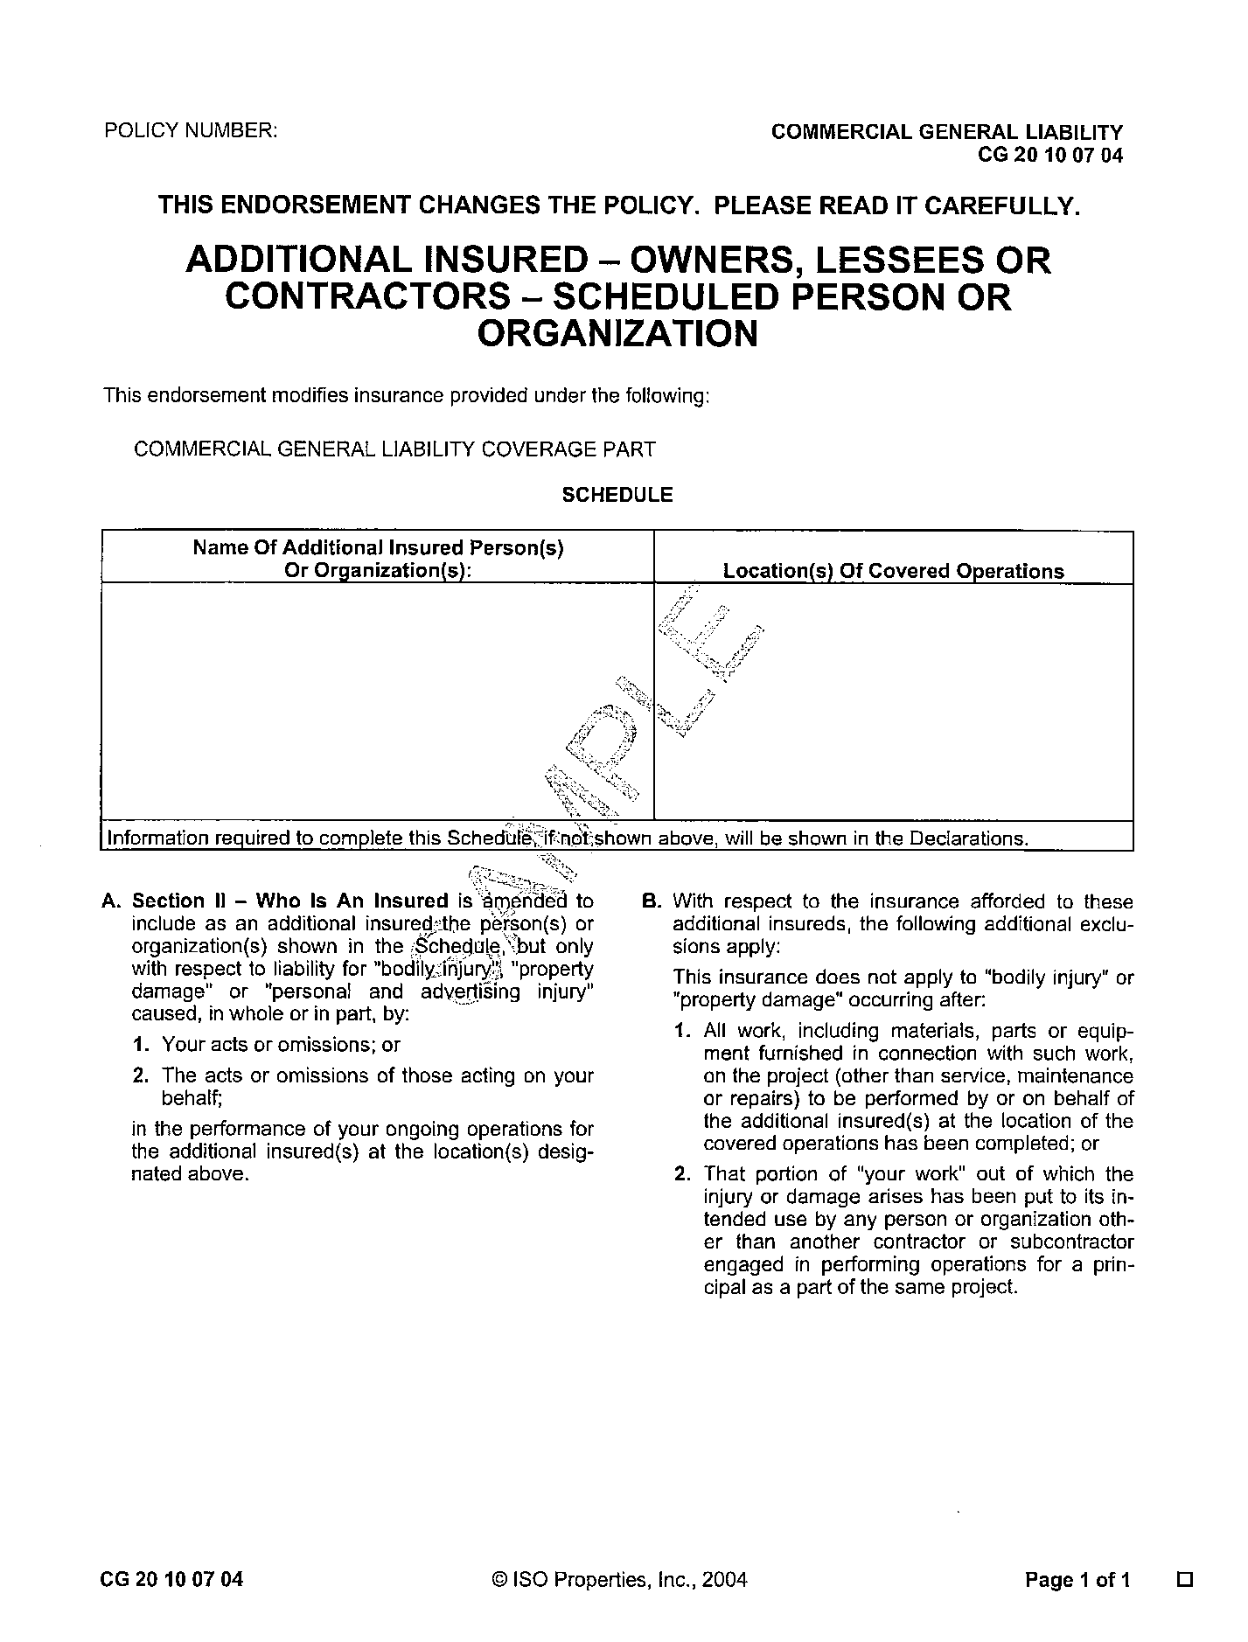
EXHIBIT A

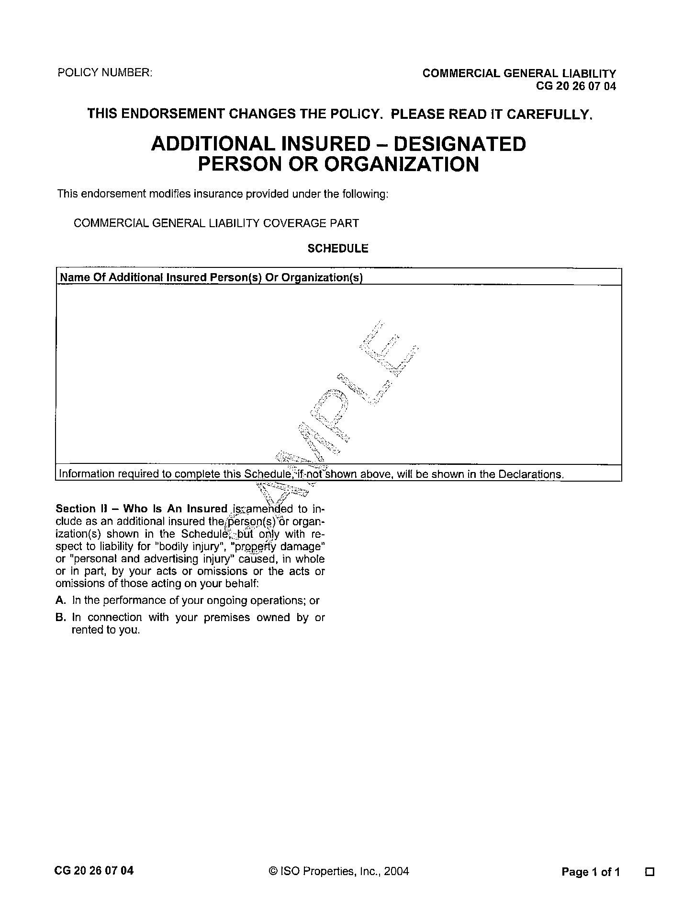
EXHIBIT B

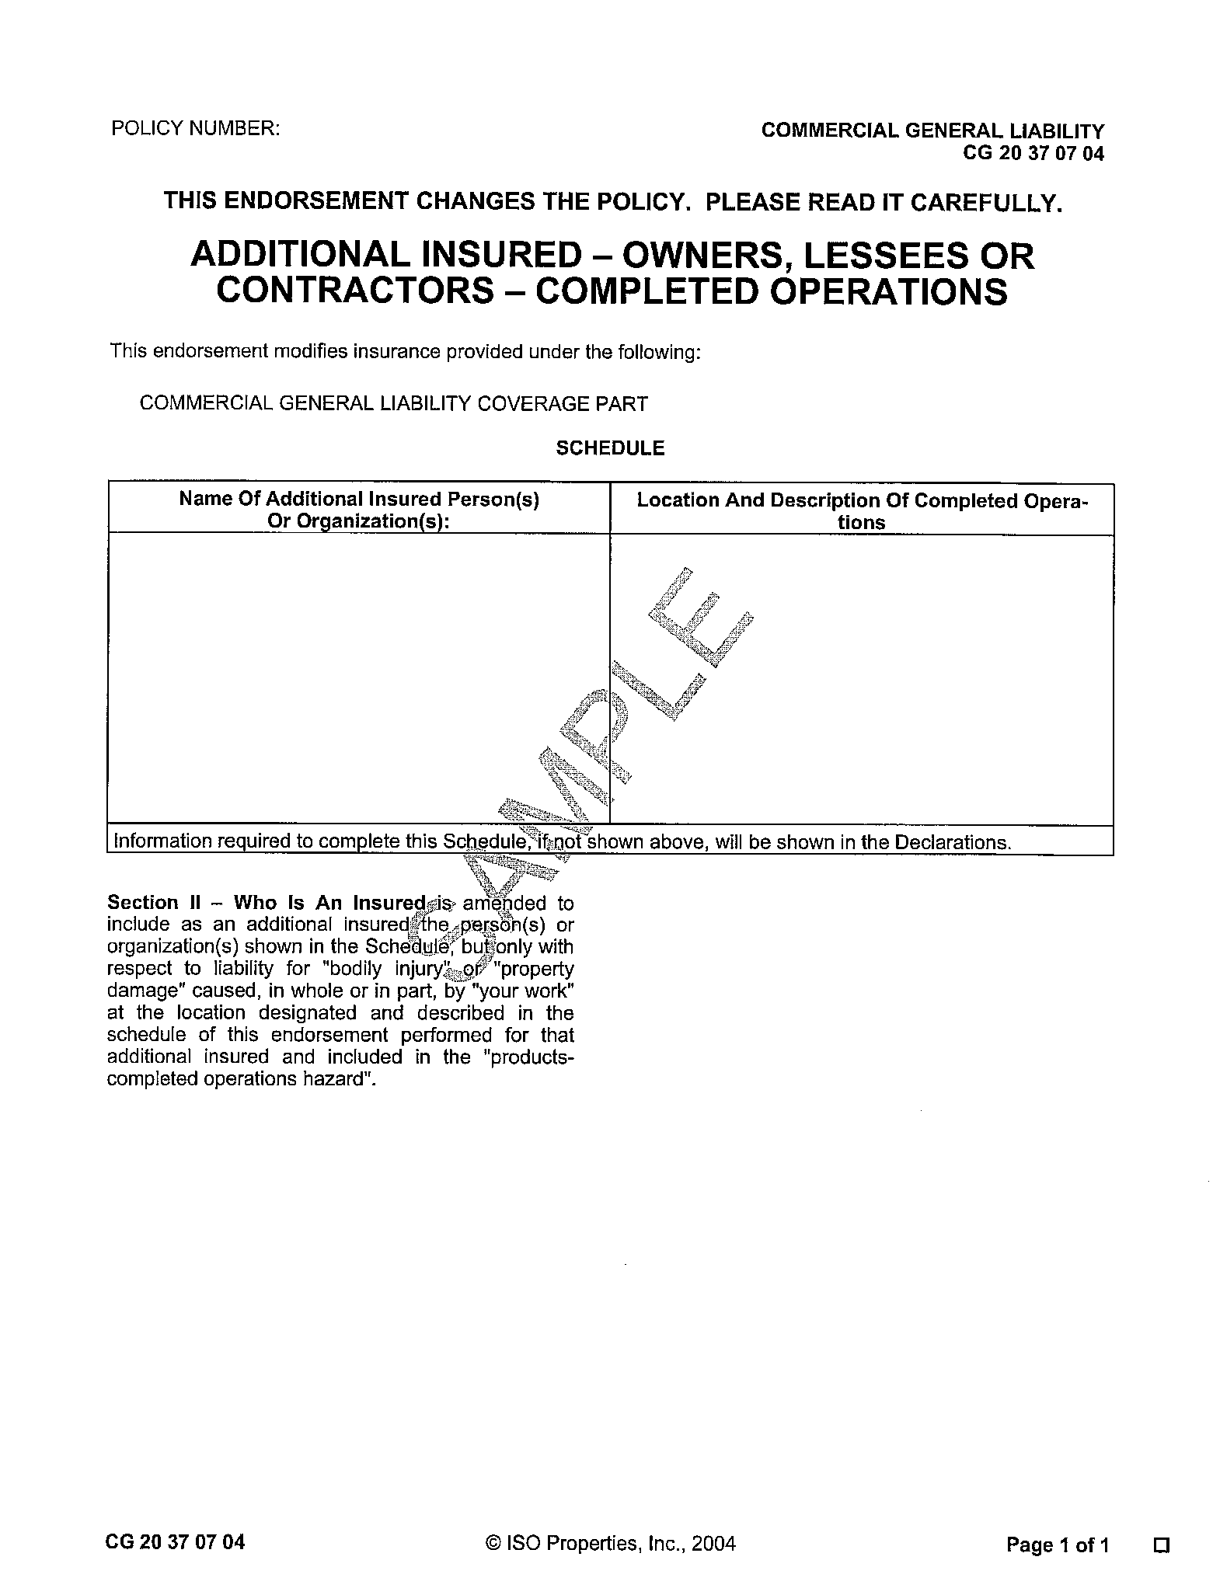
EXHIBIT C

- Failure to Comply: In the event the Contractor fails to obtain or maintain any insurance coverages required under this agreement, the Municipality may purchase such insurance coverages and charge the expense thereof to the Contractor.
- Hold Harmless: The Contractor agrees to indemnify, save harmless and defend the Village of Cary, Village of Algonquin, City of McHenry, City of Woodstock, and their respective elected and appointed officials, employees, agents, consultants, attorneys and representatives and each of them against and hold it and them harmless from any and all lawsuits, claims, injuries, demands, liabilities, losses, and expenses; including court costs and attorney’s fees for or on account of any injury to any person, or any death at any time resulting from such injury, or any damage to property, which may arise or which may be alleged to have arisen out of, or in connection with the work covered by this project. The foregoing indemnity shall apply except if such injury is caused directly by the willful and wanton conduct of the Municipalities its agents, servants, or employees or any other person indemnified hereafter. The obligations of the Contractor under this provision shall not be limited by the limits of any applicable insurance required of the Contractor. The indemnification obligations under this paragraph shall not be limited in any way by any limitation on the amount or type of damages, compensation, or benefits payable by or for the Contractor or any subcontractor under Workers’ Compensation or Disability Benefit Acts or Employee Benefit Acts.

10. Submission of Bidder's Proposal

One copy of each Bidder's Proposal, properly signed, together with all other required documents, shall be enclosed in a sealed envelope or package and shall be addressed and delivered to the place, before the time, and in the manner designated. All Bidder's Proposals received after the time for the opening of bids specified will be returned unopened.

Each sealed envelope or package containing a Bidder's Proposal shall be identified as such and shall be marked with the title of the Contract and Bidder's full legal name. All Addenda will be considered part of each Bidder's Proposal whether attached or not.

11. Withdrawal of Bidder's Proposal

Any Bidder's Proposal may be withdrawn at any time prior to the opening of any Bidder's Proposal, provided that a request in writing, executed by Bidder in the manner specified in Section 7 of these General Instructions to Bidders, for the withdrawal of such Bidder's Proposal is filed with Owner prior to the opening of any Bidder's Proposal. The withdrawal of a Bidder's Proposal prior to opening of any Bidder's Proposal will not prejudice the right of Bidder to file a new Bidder's Proposal.

No Bidder's Proposal shall be withdrawn without the consent of Owner for a period of sixty (60) days after the opening of any Bidder's Proposal. Any Bidder's Proposal may be withdrawn at any time following the expiration of said sixty (60) day period, provided that the Bidder has not been awarded the contract and that a request in writing, executed by Bidder in the manner specified in Section 7 of these General Instructions to Bidders, for the withdrawal of such Bidder's Proposal is filed with Owner after said sixty (60) day period. If no such request is filed, the date for acceptance of such Bidder's Proposal shall be deemed to be extended until such a request is filed or until Owner executes a Contract until Owner affirmatively and in writing rejects such Bidder's Proposal.

12. Qualification of Bidders

- Factors. Owner intends to award the Contract only to a Bidder that furnishes satisfactory evidence that it has the requisite experience, ability, capital, facilities, plant, organization and staffing to enable it to perform the Work successfully and promptly and to complete the Work for the Contract Price and within the Contract Time.

- Additional Information. Owner reserves the right to require from any Bidder, prior to award of the Contract, a detailed statement regarding the business and technical organizations and plant of Bidder that is available for the Work. Information pertaining to financial resources, experience of personnel, contract defaults, litigation history, and pending construction projects may also be requested.

- Final Determination. The final selection of the successful Bidder shall be made on the basis of the amount of the Bidder's Price Proposals, Owner's prior experience with the Bidders, Owner's knowledge of the Bidders' performance on other relevant projects, any additional information submitted by Bidders to satisfy Owner that Bidders are adequately prepared to fulfill the Contract, and all other relevant facts or matters mentioned in the Bid Package or that Owner may legally consider in making its determination.

13. Disqualification of Bidders

- More Than One Bidder's Proposal. No more than one Bidder's Proposal for the Work described in the Contract shall be considered from any single corporation, partnership, individual or joint venture, whether under the same or different names and whether or not in conjunction with any other corporation, partnership, individual or joint venture. Reasonable grounds for believing that any corporation, partnership, individual or joint venture is interested in more than one Bidder's Proposal for the Work may cause the rejection of all Bidder's Proposals in which such corporation, partnership, individual or joint venture is interested. Nothing contained in this Subsection 12A shall prohibit any single corporation, partnership, individual or joint venture, whether under the same or different names and whether or not in conjunction with any other corporation, partnership, individual or joint venture, from submitting a bid or quoting prices to more than one Bidder for equipment, materials and supplies or labor to be furnished as a subcontractor or supplier.

- Collusion. If there are reasonable grounds for believing that collusion exists among any Bidders, all Bidder's Proposals of the participants in such collusion will not be considered.

- Default. If a Bidder is or has been in default on a contract with Owner or in the payment of monies due Owner, its Bidder's Proposal will not be considered.

14. Award of Contract

- Reservation of Rights. Owner reserves the right to accept the Bidder's Proposal that is, in its judgment, the best and most favorable to the interests of Owner and the public; to reject the low Price Proposal; to accept any item of any Bidder's Proposal; to reject any and all Bidder's Proposals; to accept and incorporate corrections, clarifications or modifications following the opening of the Bidder's Proposals when to do so would not, in Owner's opinion, prejudice the bidding process or create any improper advantage to any Bidder; and to waive irregularities and informalities in the bidding process or in any Bidder's Proposal submitted; provided, however, that the waiver of any prior defect or informality shall not be considered a waiver of any future or similar defects or informalities, and Bidders should not rely upon, or anticipate, such waivers in submitting their Bidder's Proposals.

- Firm Offers. All Bidder's Proposals are firm offers to enter into the Contract and no Bidder's Proposals shall be deemed rejected, notwithstanding acceptance of any other Bidder's Proposal, until the Contract has been executed by both Owner and the successful Bidder or until Owner affirmatively and in writing rejects such Bidder's Proposal

- Time of Award. It is expected that the award of the Contract, if it is awarded, will be made within sixty (60) days following the opening of the Bidder's Proposals. Should administrative difficulties be encountered after the opening of the Bidder's Proposals, including the annulment of any award, that may delay an award or subsequent award beyond such sixty (60) day period, Owner may accept any Bidder's Proposal for which the date for acceptance has been extended as provided in Section 10 of these General Instructions to Bidders in order to avoid the need for re-advertisement. No Bidder shall be under any obligation to extend the date for acceptance of its Bidder's Proposal. Failure of one or more of the Bidders or their sureties to extend the date for acceptance of its Bidder's Proposal shall not prejudice the right of Owner to accept any Bidder's Proposal for which the date for acceptance has been extended.

15. Notice of Award; Effective Date of Award

If the Contract is awarded by Owner, such award shall be effective when a Notice of Award in the form included in the Bid Package has been delivered to the successful Bidder (“Effective Date of Award”). Owner will prepare five (5) copies of the Contract based upon Bidder's Proposal and will submit them to the successful Bidder with the Notice of Award.

16. Closing of Contract

- Closing Date. Unless otherwise stated in the Notice of Award, the successful Bidder shall satisfactorily complete all Conditions Precedent to Closing before, and the Contract and all related documents shall be executed, submitted and exchanged by Owner and Bidder (“Closing”) on, the tenth day following the Effective Date of Award or within such extended period as Owner may, in the exercise of its sole discretion, authorize in writing after issuance of the Notice of Award (“Closing Date”).

- Conditions Precedent to Closing. On or before the Closing Date, the successful Bidder shall: (1) sign (see Section 7), date as of the Closing Date, and submit to Owner all five copies of the Contract, the Contractor's Certification, and all other required documentation related to the Contract on or before the Closing Date; and (2) submit five executed copies of all required Bonds dated as of the Closing Date and all certificates and policies of insurance required by the Bid Package.

Failure to timely execute or submit any of the aforesaid documents shall be grounds for the imposition of liquidated damages as more specifically set forth in Section 8 above. If the submitted documents or any of them fail to comply with these General Instructions to Bidders or the Contract or are not timely executed and submitted, Owner may, in its sole discretion, annul the award or allow the successful Bidder an opportunity to correct the deficiencies.

In no event will Owner execute the Contract until any and all such deficiencies have been cured or Owner has received adequate assurances, as determined by Owner, of complete and prompt performance.

- Closing. At the Closing, and provided that all documents required to be submitted prior to or at the Closing have been reviewed and determined by Owner to be in compliance with these General Instructions to Bidders and the Contract, or assurances of complete and prompt performance satisfactory to Owner have been received, Owner shall execute all copies of the Contract, retain three copies of the completed Contract, and tender two copies to the successful Bidder at the Closing. The successful Bidder shall tender one copy to its surety company or companies. The successful Bidder or its agent shall be present at the Closing.

17. Failure to Close

- Annulment of Award; Liquidated Damages. The failure or refusal of a successful Bidder to comply with the Conditions Precedent to Closing or to Close shall be just cause for the annulment of the award and the imposition of liquidated damages or the exercise of equitable remedies, both as more specifically set forth in Section 8 above.

- Subsequent Awards. Upon annulment of an award, Owner may accept, and award a Contract based on, any other Bidder's Proposal as Owner, in its sole judgment, deems to be the best or may invite new Proposals or may abandon the bidding process or the Work.

18. Freedom of Information Act

Each Bidder, by its submission of its Bidder’s Proposal, acknowledges that Owner is subject to the Illinois Freedom of Information Act, 5 ILCS 140/1 et seq., and that no disclosure made in good faith by Owner pursuant to such Act shall be deemed to violate this Section.

19. Joint Purchasing / Purchasing Extension

The purchase of goods and services pursuant to the terms of this Agreement shall also be offered for purchases to be made by the Municipalities, as authorized by the Governmental Joint Purchasing Act, 30 ILCS 525/0.01, et seq. (the “Act”). All purchases and payments made under the Act shall be made directly by and between each Municipality and the successful bidder. The bidder agrees that the Village of Cary shall not be responsible in any way for purchase orders or payments made by the other Municipalities. The bidder further agrees that all terms and conditions of this Agreement shall continue in full force and effect as to the other Municipalities during the extended term of this Agreement.

Bidder and the other Municipalities may negotiate such other and further terms and conditions to this Agreement (“Other Terms”) as individual projects may require. In order to be effective, Other Terms shall be reduced to writing and signed by a duly authorized representative of both the successful bidder and the other Municipality.

The bidder shall provide the other Municipalities with all documentation as required in the RFB, and as otherwise required by the Village of Cary including, but not limited to:
- 100% performance and payment bonds for the project awarded by other Municipalities;
- Certificate of insurance naming each other Municipality as an additional insured; and
- Certified payrolls to the other Municipality for work performed.

MCHENRY COUNTY AREA
PAVEMENT MANAGEMENT TASK FORCE
2016 CRACK FILLING PROGRAM JOINT BID

BIDDER’S PROPOSAL
Full Name of Bidder: |  |  |  |  |  |  | (“Bidder”)
Principal Office Address:
Local Office Address:
Contact Person:
Email: |  |  |  |  | Telephone:

To: Village of Cary (“Soliciting Agency/Owner”)
655 Village Hall Drive
Cary, Illinois 60013
Attention: Office of the Village Clerk

Bidder warrants and represents that Bidder has carefully examined the Work Site described below and its environs and has reviewed and understood all documents included, referred to, or mentioned in this bound set of documents, including any Addenda, which are securely stapled to the end of this Bidder's Proposal (“Bid Package”).

Bidder acknowledges and agrees that all terms capitalized in this Bidder's Proposal shall have the meaning given to them in the documents included in the Bid Package.

1. Work Proposal

- Contract and Work. If this Bidder's Proposal is accepted, Bidder proposes, and agrees, that Bidder will contract with Owner, in the form of the Contract included in the Bid Package: (1) to provide, perform and complete at the site or sites described in the Bid Package (“Work Site”) and in the manner described and specified in the Bid Package all necessary work, labor, services, transportation, equipment, materials, apparatus, machinery, tools, fuels, gas, electric, water, waste disposal, information, data and other means and items necessary for the Work described in Attachment A; (2) to procure and furnish all permits, licenses and other governmental approvals and authorizations necessary in connection therewith except as otherwise expressly provided in Attachment A to the Contract included in the Bid Package; (3) to procure and furnish all Bonds and all certificates and policies of insurance specified in the Bid Package; (4) to pay all applicable federal, state and local taxes; (5) to do all other things required of Contractor by the Contract; and (6) to provide, perform and complete all of the foregoing in a proper and workmanlike manner and in full compliance with, and as required by or pursuant to, the Contract; all of which is herein referred to as the “Work.”

- Additional Drawings or Specifications. Owner may, during construction, furnish such additional Contract Drawings and Specifications or such other explanations as Engineer may consider necessary to illustrate or explain the Work in further detail. The successful Bidder shall be required to comply with the requirements of all such additional Contract Drawings and Specifications or other explanations, all of which shall be considered part of the Contract and shall not be considered as indicating additional Work.

- Manner and Time of Performance. If this Bidder's Proposal is accepted, Bidder proposes, and agrees, that Bidder will perform the Work in the manner and time prescribed in the Bid Package and according to the requirements of Owner pursuant thereto.

- General. If this Bidder's Proposal is accepted, Bidder proposes, and agrees, that Bidder will do all other things required of Bidder or Contractor, as the case may be, by the Bid Package.

2. Contract Price Proposal

If this Bidder's Proposal is accepted, Bidder will, except as otherwise provided in Section 2.1 of the Contract, take in full payment for all Work and other matters set forth under Section 1 above, including overhead and profit; taxes, contributions, and premiums; and compensation to all subcontractors and suppliers, the compensation set forth on the following “Schedule of Prices” (“Price Proposal”), which Schedule of Prices Bidder understands and agrees will be made a part of the Contract:

SCHEDULE OF PRICES

COMPLETE FOLLOWING PAGE
MCHENRY COUNTY AREA
PAVEMENT MANAGEMENT TASK FORCE
2016 CRACK FILLING PROGRAM JOINT BID

SCHEDULE OF PRICES
Company Name:
Address:
Contact Person:

For providing, performing, and completing all Work, the sum of the products resulting from multiplying the number of acceptable units of Unit Price Items listed below incorporated in the Work by the Unit Price set forth below for such Unit Price Item:
ITEM NO. | PAY ITEM | TOTAL EST. QUANTITY |  | UNIT PRICE | ANNUAL COST
 |  | LIN. FT. CRACKS FILLED | LBS. OF MATERIAL APPLIED
1 | Base Bid Year 1:  Crack Sealant for Asphalt Pavement Applied | 630,000 LIN. FT. | 157,500  LBS. | $ | $
2 | Optional Year 2:  Crack Sealant for Asphalt Pavement Applied | 630,000 LIN. FT. | 157,500  LBS. | $ | $
3 | Optional Year 3:  Crack Sealant for Asphalt Pavement Applied | 630,000 LIN. FT. | 157,500  LBS. | $ | $

ITEM NO. | PAY ITEM | UNIT | UNIT PRICE
4 | Sweeper with Disposal at Municipal Facility | Per Hour | $
5 | Sweeper with Disposal Performed by the Contractor | Per Hour | $
Individual quantities for each agency in the joint bid are included in the special provisions at the end of this bid document.
BASIS FOR DETERMINING PRICES
It is expressly understood and agreed that:
- If applicable, the approximate quantities set forth in this Schedule of Prices for each Unit Price Item are estimates only, the Municipalities reserve the right to increase or decrease such quantities, and that payment for each Unit Price Item shall be made only on the actual number of acceptable units of such Unit Price Item installed complete in place, measured on the basis defined in the Contract;
- The Price Proposal includes allowances for contingencies as Bidder deems appropriate with respect to such risks and changes in the Work that Bidder or Contractor, as the case may be, is responsible for dealing with under the Contract without any equitable adjustment in the Contract Price;
- Bidder or Contractor, as the case may be, shall be compensated only in accordance with the Contract and shall not be entitled to equitable adjustments in the Contract Price as a result of any claims by Subcontractors or Suppliers arising only under their Subcontracts and not provided for in the Contract;
- Owner is not subject to state or local sales, use and excise taxes and no such taxes are included in this Schedule of Prices;
- All other applicable federal, state, and local taxes of every kind and nature applicable to the Work as well as all taxes, contributions, and premiums for unemployment insurance, old age or retirement benefits, pensions, annuities, or other similar benefits are included in this Schedule of Prices; and
- All costs, royalties, and fees arising from the use on, or the incorporation into, the Work of patented equipment, materials, supplies, tools, appliances, devices, processes, or inventions are included in this Schedule of Prices.
All claim or right to (if applicable) dispute or complain of any such estimated quantity, or to assert that there was any misunderstanding in regard to the nature or amount of any Unit Price Item to be provided or performed, or to claim any additional compensation by reason of the payment of any such tax, contribution, or premium or any such cost, royalty or fee is hereby waived and released.

3. Contract Time Proposal

If this Contract/Proposal is accepted, Bidder proposals and agrees, that Bidder shall commence the Work within 10 days following the Village’s accepted of this Contract/Proposal provided Bidder shall have furnished to Owner all bonds and all insurance certificates and policies of insurance specified in this Contract/Proposal (the “Commencement Date”).
If this Contract/Proposal is accepted, Bidder proposes, and agrees, that the Bidder shall perform the Work diligently and continuously and shall complete the Work by the Completion Date specified in the Bid Package.

4. Firm Proposal

All prices and other terms stated in this Bidder's Proposal are firm and shall not be subject to withdrawal, escalation, or change for a period of sixty (60) days after the date on which any Bidder's Proposal is opened or such extended acceptance date for Bidder's Proposals as may be established pursuant to Sections 10 and 13 of the General Instructions to Bidders.

5. Bidder Representations

- No Collusion. Bidder warrants and represents that the only persons, firms, or corporations interested in this Bidder's Proposal as principals are those named in Bidder's Sworn Acknowledgment attached hereto and that this Bidder's Proposal is made without collusion with any other person, firm or corporation.

- Not Barred. Bidder warrants, represents and certifies that it is not barred by law from contracting with Owner or with any unit of state or local government.

- Qualified. Bidder warrants and represents that it has the requisite experience, ability, capital, facilities, plant, organization and staff to enable Bidder to perform the Work successfully and promptly and to commence and complete the Work within the Contract Price and Contract Time Proposals set forth above. In support thereof, Bidder submits the attached Sworn Work History Statement. In the event Bidder is preliminarily deemed to be one of the most favorable to the interests of Owner, Bidder hereby agrees to furnish upon request, within two (2) business days or such longer period as may be set forth in the request, such additional information as may be necessary to satisfy Owner that Bidder is adequately prepared to fulfill the Contract.

- Owner's Reliance. Bidder acknowledges that Owner is relying on all warranties, representations and statements made by Bidder in this Bidder's Proposal.

6. Surety and Insurance
Bidder herewith tenders surety and insurance commitment letters.

7. Bid Security

Bidder herewith tenders a Cashier's Check, Certified Check, or Bid Bond for the sum of _________________ dollars ($____________), which is equal to at least ten percent (10%) of Bidder's Price Proposal (“Bid Security”).

8. Owner's Remedies

Bidder acknowledges and agrees that should Bidder fail to timely submit all additional information that is requested of it; or should Bidder, if Owner awards Bidder the Contract, fail to timely submit all the Bonds and all the certificates and policies of insurance required of it; or should Bidder, if Owner awards Bidder the Contract, fail to timely execute the Contract, Contractor's Certification and all other required documentation related to the Contract, it will be difficult and impracticable to ascertain and determine the amount of damage that Owner will sustain by reason of any such failure and, for such reason, Owner shall have the right, at its option in the event of any such default by Bidder, to retain or recover as reasonably estimated liquidated damages, and not as a penalty, the entire amount of the Bid Security or ten percent of Bidder's Price Proposal, whichever is greater, or to exercise any and all equitable remedies it may have against Bidder.

9. Owner's Rights

Bidder acknowledges and agrees that Owner reserves the right to reject any and all Bidder's Proposals, reserves the right to accept or reject any item of any Bidder's Proposal and reserves such other rights as are set forth in Section 13 of the General Instructions to Bidders.

10. Bidder's Obligations

In submitting this Bidder's Proposal, Bidder understands and agrees that it shall be bound by each and every term, condition or provision contained in the Bid Package, which are by this reference incorporated herein and made a part hereof.

DATED this ________ day of _________________, 20_______.

Attest/Witness: | __________________________________________  Bidder
By: _______________________ | By: ____________________________________
Title: _______________________ | Title: ____________________________________
BIDDER'S SWORN ACKNOWLEDGEMENT

_______________________________ (“Deponent”), being first duly sworn on
oath, deposes and states that the undersigned Bidder is organized as indicated below and that all statements herein made are made on behalf of such Bidder in support of its Bidder's Proposal for the above Contract and that Deponent is authorized to make them.

Deponent also deposes and states that Bidder has carefully prepared, reviewed
and checked its Bidder's Proposal and that the statements contained in its Bidder's Proposal and in this Acknowledgement are true and correct.

COMPLETE APPLICABLE SECTION ONLY

1. Corporation

Bidder is a corporation that is organized and existing under the laws of the State
of ____________, that is qualified to do business in the State of Illinois, and that is operating under the legal name of ____________________________________________.

The officers of the corporation are as follows:

TITLE | NAME | ADDRESS
President | ____________________ | ______________________________
Vice President | ____________________ | ______________________________
Secretary | ____________________ | ______________________________
Treasurer | ____________________ | ______________________________

2. Partnership

ACKNOWLEDGEMENT

Bidder is a partnership that is organized, existing and registered under the laws of the State of ____________________ pursuant to that certain Partnership Agreement dated as of ___________________, that is qualified to do business in the State of Illinois, and that is operating under the legal name of _________________________________________.
The general partners of the partnership are as follows:

NAME | ADDRESS
____________________ | ________________________________________________
____________________ | ________________________________________________
____________________ | ________________________________________________
____________________ | ________________________________________________
____________________ | ________________________________________________

3. Individual

Bidder is an individual whose full name is _____________________________,
whose residence address is __________________________________________________ and whose business address is __________________________________. If operating under a trade or assumed name, said trade or assumed name is as follows: ___________________________.

4. Joint Venture

Bidder is a joint venture that is organized and existing under the laws of the State
of ________ pursuant to that certain Joint Venture Agreement dated as of ______________, that is qualified to do business in the State of Illinois, and that is operating under the legal name of ______________________________.

The signatories to the aforesaid Joint Venture Agreement are as follows:

NAME (and ENTITY TYPE) ADDRESS

_________________(________) ____________________________________________

_________________(________) ____________________________________________

_________________(________) ____________________________________________

[For each signatory, indicate type of entity (Corporation = “C”; Partnership = “P”; and Individual = “I”) and provide, on separate sheets, the information required in Paragraph 1, 2, or 3 above, as applicable]

ACKNOWLEDGEMENT

DATED this ______ day of ____________, 20___.

Attest/Witness: __________________________________________
Bidder

By: _______________________ By: ____________________________________

Title: _______________________ Title: ____________________________________

Subscribed and Sworn to My Commission Expires:

_______________ before me this ____ day of _____________, 20___.

___________________________ [SEAL]
Notary Public

SEE GENERAL INSTRUCTIONS TO BIDDERS, SECTION 7,
FOR SIGNATURE REQUIREMENTS

BIDDER'S SWORN WORK HISTORY STATEMENT

_______________________________ (“Deponent”), being first duly sworn on
oath, deposes and states that all statements made in this Sworn Work History Statement are made on behalf of the undersigned Bidder in support of its Bidder's Proposal for the above Contract and that Deponent is authorized to make them.

Deponent also deposes and states that Bidder has carefully prepared, reviewed
and checked this Sworn Work History Statement and that the statements contained in this Sworn Work History Statement are true and correct.

IF NECESSARY FOR FULL DISCLOSURE, ADD SEPARATE SHEETS

JOINT VENTURES MUST SUBMIT SEPARATE
SWORN WORK HISTORY STATEMENTS FOR THE JOINT VENTURE
AND FOR EACH SIGNATORY TO THE JOINT VENTURE AGREEMENT

1. Nature of Business

State the nature of Bidder's business:

2. Composition of Work

During the past three years, Bidder's work has consisted of:

3. Years in Business

State the number of years that Bidder, under its current name and organization, has been continuously engaged in the aforesaid business: _________ Years

4. Predecessor Organizations

If Bidder has been in business under its current name and organization for less than five years, list any predecessor organizations:

NAME ADDRESS YEARS

____________________ __________________________________ _______

____________________ __________________________________ _______

5. Business Licenses

List all business licenses currently held by Bidder:

ISSUING AGENCY | TYPE | NUMBER | EXPIRATION
__________________________ | __________ | __________ | _____________
__________________________ | __________ | __________ | _____________

6. Related Experience

List three projects most comparable to the Work completed by Bidder, or its predecessors, in the past five years:

 | PROJECT ONE | PROJECT TWO |  | PROJECT THREE
Owner Name | ______________ | ______________ |  | __________________
Owner Address | ______________ | ______________ |  | __________________
 | ______________ | ______________ |  | __________________
Reference | ______________ | ______________ |  | __________________
Telephone Number | ______________ | ______________ |  | __________________
Type of Work | ______________ | ______________ |  | __________________
 | ______________ | ______________ |  | __________________
 | PROJECT ONE | PROJECT TWO | PROJECT THREE
Contractor  (If Bidder was) | ______________ | ______________ | __________________
(Subcontractor) | ______________ | ______________ | __________________
 | ______________ | ______________ | __________________
Amount of Contract | ______________ | ______________ | __________________
Date Completed | ______________ | ______________ | __________________

DATED this ______ day of ____________, 20__.

Attest/Witness: __________________________________________
Bidder

By: _______________________ By: ____________________________________

Title: _______________________ Title: ____________________________________

Subscribed and Sworn to My Commission Expires:

_______________ before me this ____ day of _____________, 20___.

___________________________ [SEAL]
Notary Public

SEE GENERAL INSTRUCTIONS TO BIDDERS, SECTION 7,
FOR SIGNATURE REQUIREMENT
MCHENRY COUNTY AREA
PAVEMENT MANAGEMENT TASK FORCE
2016 CRACK FILLING PROGRAM JOINT BID

SPECIAL PROVISIONS

The following Special Provisions supplement the “Standard Specifications for Road and Bridge Construction”, adopted January 1, 2012 or latest addition, (hereinafter referred to as the Standard Specifications) and latest edition of the “Illinois Manual on Uniform Traffic Control Devices for Street and Highways” in effect on the date of invitations for bid. In case of conflict with any part or parts of said specifications, the said Special Provisions shall take precedence and shall govern.
The term “Municipalities” and “Village” refers to the Village of Algonquin, Illinois; Village of Cary, Illinois; City of McHenry, Illinois; and City of Woodstock, Illinois.

DESCRIPTION OF IMPROVEMENT
The Contractor shall be responsible for routing, cleaning, and filling certain asphalt pavement cracks throughout the Municipalities at locations determined by the municipal representative. Only sections of crack that are identified at each location and listed on the crack filling list or map shall be routed, cleaned, filled and accounted for in the Schedule of Prices. The Contractor is not guaranteed the total annual quantity as listed in the Schedule of Prices under the items of CRACK SEALANT FOR ASPHALT PAVEMENT APPLIED (as stated previously in the OTHER SPECIAL PROVISIONS). The Contractor shall complete the work as shown on the replacement list or map provided by the Municipalities after award of the contract.
The Contractor shall also be fully responsible for removing material on the pavement or on nearby or adjacent property generated as a result of the Work.

AWARD OF CONTRACT
The Contract shall be awarded to the lowest, responsible bidder for performance of the total Work as listed in the Schedule of Prices.

CONTRACT TIME
Contractor shall complete the Work no later than August 19, 2016, unless otherwise approved in writing by the Municipality’s representative.
WORKING HOURS
No work shall be performed between 7:00pm and 7:00am, but not on Saturdays, Sundays, or legal holidays without written permission of the Owner. However, emergency work may be done with permission from the Municipality’s representative.

TRAFFIC CONTROL AND SITE SAFETY
The Contractor is responsible to provide Traffic Control that meets the requirements specified in Section 701 of the Standard Specifications. Traffic Control is considered incidental to this Contract.
The Contractor shall contact the Village at least 72 hours in advance of beginning work. Construction operations shall be conducted in a manner such that streets will be open to emergency traffic and accessible as required to local traffic. Advanced notice shall be provided to residents, police, fire, school districts and trash haulers when access to any street will be temporarily closed or limited. Crack filling work shall be planned so as to cause a minimum of inconvenience to the adjacent property owners.

LOCATION OF THE IMPROVEMENT
Locations to be determined based on areas damaged due to emergency or routine repairs of the municipality’s utility infrastructure, routine field inspections by municipal personnel and resident service requests. Addresses and or maps showing all of the replacement locations shall be provided to the contractor.

EXISTING UTILITIES
The Contractor is notified that there is expected to be no effect on any utility lines or conduits during construction of this project due to the shallow nature of the routing of the pavement cracks. However, the Municipalities shall bear no responsibility for any conflicts and it shall be the Contractor’s responsibility to make his own investigation to determine the existence, nature, and location of all utility lines and appurtenances within the limits of the improvement.

PAYMENT
Each request for payment of the Contract Price shall be itemized so as to indicate the portion of the requested payment that is allocable to Work performed by Contractor. Once the municipal representative has certified the completion and quality of the Work, payment will be made to Contractor.
Bidders will provide pricing for this contract per LINEAL FOOT of crack filled with an equivalent pound of crack sealant to be provided and installed per the specifications contained herein. A bidder’s per-foot and equivalent per-pound pricing will include all of its costs, including its costs for materials, installation services, and the providing of advance notice about these services to residences.
Pricing per hour must be submitted for street sweeping with disposal by the Contractor and pricing per hour for street sweeping with disposal at Municipal facility.
The Contractor’s pricing under the optional renewals allowed by this RFB must be indicated in the bid proposal.

OTHER SPECIAL PROVISIONS
  - Equipment used for heating and placing the premixed material shall be capable of heating the material to 400° F and pumping the material into the prepared cracks.
  - All temperature gauges shall be calibrated and checked for accuracy.
  - Crack sealing material shall be a rubberized material that conforms to section 451 and section 1050.02 of the IDOT standard specifications, current edition. Prior to beginning work, the contractor shall submit to the Municipality’s representative a manufacturer’s certificate stating that the crack sealing material complies with the above requirements.
  - Crack routers/cutters shall be mechanical and power driven, capable of cutting the cracks to the required dimensions. Equipment designed to “plow” the cracks will not be permitted.
  - Crack routing dimensions shall not exceed three-quarter inch (3/4”) wide, by three-quarter inch (3/4”) deep. Dimensions that exceed this must be approved by the Municipality’s representative.
  - Air compressors shall provide moisture and oil-free compressed air and shall be of sufficient size to blow sand and other foreign material from the crack prior to placing the crack sealing material.
  - High temperature (2700 FPS avg.) and high air velocity (1900 FPS avg.) crack blowing equipment shall be used to perform final crack blowing and lancing.
  - Crack cleaning and filling shall be done only when ambient air and pavement surface temperatures are above 40° F. When near this minimum, additional air blasting or drying time, or both, may be necessary to ensure a satisfactory bond to the crack surfaces. Crack sealing material shall be heated on the job, not to exceed 400° F.

  - Crack sealant shall be applied so that the crack is flush filled immediately following application and a thin over-band of sealant extends approximately one inch (1”) beyond the edges of the crack. Excess crack sealant shall be removed from the pavement surface immediately following application. Removal shall involve the use of a squeegee, starting from the centerline and proceeding towards the shoulder or curb.
  - Each Municipality will determine if the Contractor will sweep and remove all debris from routing of the cracks or if the sweeping and removal of debris will be performed by the Municipality. On the pricing chart, the contractor shall provide a price per hour for the cost of sweeping and removing all debris.
  - Each Municipality shall also decide if the Contractor shall be responsible for the disposal of debris from sweeping or if the Contractor is to transport debris to a Municipality facility location as determined by the Director of Public Works or his/her designee. If transported, only debris from crack sealing operation will be allowed to be dumped at the Municipal facility.
  - Upon completion of sweeping and collection of debris, all roadways and/or parking areas must present an appearance that is completely satisfactory to the Municipality’s representative.
  - Traffic shall be permitted to cross sealant for a time period no less than ten minutes from the time sealant has been applied.
  - The Contractor shall provide sufficient supervision and personnel to carry out the project in a timely manner and with a minimum of delay in time.
  - The Contractor is responsible for damage claims as per applicable articles of Section 107 of the Standard Specifications. The Contractor’s certificate of insurance shall meet the requirements of Article 107.27 of the Standard Specifications. In addition, under Article 107.27 of the Standard Specifications, the Contractor’s policy of insurance shall also include the Municipalities and consultant engineers (if applicable) as the additional insured.
  - The Municipalities reserve the right to delete any portion of their project if it is in the best interest of the Municipalities to do so. Any portion deleted from the contract shall have no bearing on the remaining work under the terms of this Contract or unit prices.
  - The Municipalities reserve the right to appoint an employee or other representative to inspect all work completed under this contract.
  - The Municipalities shall provide lists of roads that shall be completed in this contract.
  - Contractor must provide notification of where and when work will be done each day (preferably at least 24 hours in advance).
  - The Contractor, at its sole expense, shall develop, print, and distribute to all affected residences a standardized door hanger, letter, or postcard (pre-approved by the Municipalities) that will provide advance notice to these residences of the crack sealing operations the Contractor will undertake. Affected residences will include all residences on each of the blocks on which the Contractor will provide crack sealing services for the Municipalities. The Contractor shall provide residences notice no later than 72 hours prior to the undertaking of its crack sealing operations on their block. The Municipalities, at their discretion, may furnish the Contractor with a sample document deemed suitable for notification.
  - Each Municipality may provide the Contractor space at its Public Works facility to store equipment while the Contractor is providing the Municipality crack sealing services. In exchange for storage space, the Contractor shall identify the discount to each Municipality if space is provided. Access to facilities shall be established with the successful bidder.

SCHEDULE OF QUANTITIES – BY INDIVIDUAL AGENCY
The approximate quantities set forth in the table below for each item are estimates only and each municipality reserves the right to increase or decrease such quantities based on the Standard Specifications.
 | MUNICIPALITY
 | ALGONQUIN |  | CARY |  | MCHENRY |  | WOODSTOCK
 | LBS | LIN FT* | LBS. | LIN FT* | LBS | LIN FT* | LBS | LIN FT*
BASE BID YEAR 1:  CRACK SEALANT FOR ASPHALT PAVEMENT | 12,500 LBS | 50,000 LF | 30,000 LBS | 120,000 LF | 52,500 LBS | 210,000 LF | 62,500 LBS | 250,000 LF
OPTIONAL YEAR 2:  CRACK SEALANT FOR ASPHALT PAVEMENT | 12,500 LBS | 50,000 LF | 30,000 LBS | 120,000 LF | 52,500 LBS | 210,000 LF | 62,500 LBS | 250,000 LF
OPTIONAL YEAR 3:  CRACK SEALANT FOR ASPHALT PAVEMENT | 12,500 LBS | 50,000 LF | 30,000 LBS | 120,000 LF | 52,500 LBS | 210,000 LF | 62,500 LBS | 250,000 LF
* Item is paid per foot of crack filled or the equivalent pound of material applied. The linear feet listed above is for reference only and is estimated based upon 25 lbs. of material required for 100 linear feet of ¾”wide x ¾” deep cracks.

APPENDIX A

AGREEMENT ACCEPTANCE

CRACK SEALING SERVICES

ACCEPTANCE

The Contract/Proposal attached hereto and by this reference incorporated herein and made a part hereof is hereby accepted by the order of [insert Municipality name] ("Owner") this ________day of _________________, 20__.

This Acceptance, together with the Contract/Proposal attached hereto, constitutes the entire and only agreement between the parties relating to the accomplishment of the Work and the compensation therefore and supersedes and merges any other prior or contemporaneous discussions, agreements, or understandings, whether written or oral, and shall prevail over any contradictory or inconsistent terms or conditions contained in any purchase order, acceptance, acknowledgement, invoice, or other standard form used by the parties in the performance of the Contract/Proposal. Any such contradictory or inconsistent terms or conditions shall be deemed objected to by Owner without further notice of objection and shall be of no effect nor in any circumstances binding upon Owner unless accepted by Owner in a written document plainly labeled "Amendment to Contract/Proposal." Acceptance or rejection by Owner or any such contradictory or inconsistent terms or conditions shall not constitute acceptance of any other contradictory or inconsistent terms or conditions.

by: __________________________________________

Title:

