WHEREAS, safe accommodations for all users and a connected network are important needs of any transportation system; and

WHEREAS, Complete Streets are defined as improvements that provide safe, connected transportation networks for pedestrians, cyclists, transit users, freight, emergency services, and motor vehicles including but not limited to bicycle facilities, streetscaping, pedestrian treatments, refuge islands, access control and lower speeds on local roads; and

WHEREAS, [MUNICIPALITY] recognizes the need to accommodate all modes of transportation because of the associated improvements to safety, the environment, quality of life, health, and economic development; and

WHEREAS, many jurisdictions within McHenry County and the Chicago region have already adopted Complete Streets policies; and

WHEREAS, by adopting a Complete Streets policy the [MUNICIPALITY] is helping to implement the region’s ON TO 2050 Plan and will therefore be entitled to bonus points during the upcoming 2020 STP-L Call for Projects.

NOW, THEREFORE, BE IT RESOLVED that the [MUNICIPALITY], by this resolution, adopts the Complete Streets Policy attached as Exhibit A.

DATED

(City/Village)
Complete Streets Policy
(Date)

- VISION
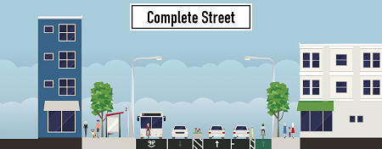
Complete Streets provides significant health, safety, environmental, economic, and social benefits. By accommodating all users of our transportation system, including pedestrians, cyclists, transit users, freight trucks, and single-occupancy vehicles, the Choose an item. can capitalize on the numerous other benefits of Complete Streets. The Choose an item. supports the creation of amenities that enhance the quality of life of residents and improve the physical and social environment in ways that attract businesses and workers. The purpose of this policy is to, first and foremost, ensure that all users of the transportation system are accommodated. This policy directs the Choose an item. to develop and maintain a safe and equitable transportation system that anyone can access, utilize, and enjoy. This policy shall be observed when planning, designing, constructing, and operating Choose an item. streets.
Cross-section of a Complete Street. The street accommodates bus riders, cyclists, pedestrians, and motor vehicles.
Goals
- Enhance roadway safety for pedestrians, bicyclists, and motor vehicles
- Provide a variety of choices for active, non-motorized transportation to routine destinations
- Increase the capacity and efficiency of the transportation network, reduce traffic congestion, and improve air quality by improving mobility options
- To create a comprehensive, integrated, and connected transportation network
- To recognize the need for flexibility to accommodate different types of streets and users
- Promote environmental benefits such as preserving the natural environment and reducing greenhouse gas emissions
- Improve the local economy by creating quality of life resources for the City residents and promoting sustainable development
- Improve health and physical fitness among residents
- Create aesthetically beautiful and physically pleasant streets for all modes
- To ensure that the Complete Streets design solutions fit within the context(s) of the community

- DIVERSE USERS
The Choose an item. shall ensure that the safety and convenience of all users of the transportation system are accommodated, including pedestrians, bicyclists, transit riders, people of all ages and abilities, motorists, emergency responders, freight providers, and adjacent land users. Vulnerable users in particular will be prioritized. Those with disabilities and senior citizens shall be given extra consideration in the design and planning processes.
When there are conflicting needs among users and modes, the following prioritization will apply:
- Above all, safety is paramount, followed by mobility
- Among modes, pedestrians shall come first citywide, followed by the next most vulnerable types of users
- Seek balance among all modes involved
It is recognized that all modes cannot receive the same type of accommodation and space on every street, but the overall goal is that everyone – young, old, and of varying ability – can safely and conveniently travel across the network using whatever mode they choose.

- PROJECTS AND PHASES
The Choose an item. shall approach every transportation project phase as an opportunity to create safer, more accessible streets for all users. These phases include, but are not limited to: planning, programming, design, right-of-way acquisition, construction, construction engineering, reconstruction, operation and maintenance. Other changes to transportation facilities on streets and rights-of-way, including capital improvements, re-channelization projects and major maintenance, must also be included.
- EXEMPTIONS
There may be a number of reasons why implementation is not feasible. The following are considered reasonable exemptions from policy implementation:
- The cost of providing full accommodation would be excessively disproportionate to the need or probability of use, now or in the future;
- Accommodation is not practically feasible because of severe topographic constraints or significant adverse impacts to the natural environment, historic or cultural resources, or neighboring land uses;
- The project is under construction or in the final design stages at the time of the adoption of this Policy
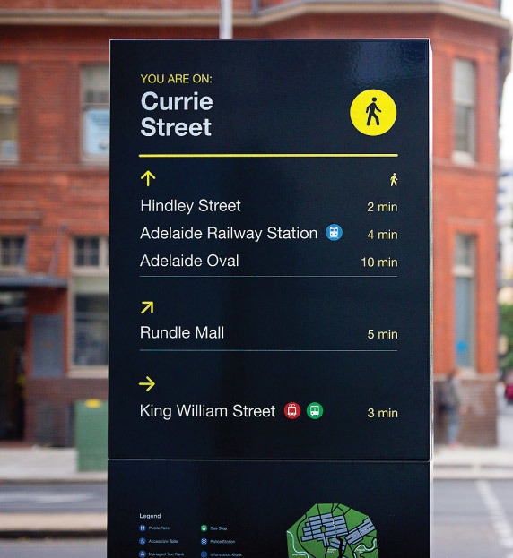
- A reasonable and equivalent alternative already exists for certain users or is programmed as a separate project
- The existing and planned population, employment densities, traffic volumes, or level of transit service around a particular roadway, as documented by the [appropriate plan/s], is so low as a to demonstrate an absence of current and future need
- The [Public Works] Director issues a documented exemption concluding that the application of Complete Streets principles is unnecessary, unduly cost prohibitive, or inappropriate because it would be contrary to public safety
When projects are exempted from the Policy, a greater effort shall be made to accommodate affected users elsewhere, including on adjacent streets and on streets that intersect with the street or facility.
Wayfinding is an essential part of Complete Streets.
- NETWORK
This Policy shall result in a comprehensive, integrated, and connected transportation network for all modes. This ensures that the needs of all users are met, regardless of mode.
- JURISDICTIONS
This Policy shall apply to all city (or village) owned transportation facilities in the public right-of-way including but not limited to: streets, sidewalks, alleys, bridges, trails, parking lots, and all other connecting pathways.
Looking to the future, the City shall also foster partnerships with other agencies that further the City’s vision of a connected, integrated transportation network that reaches beyond city borders. Partners should include but not be limited to:
- Illinois Department of Transportation
- McHenry County Division of Transportation
- Township Highway Departments
- School Districts
- Local businesses
- Private developers
- Neighboring communities

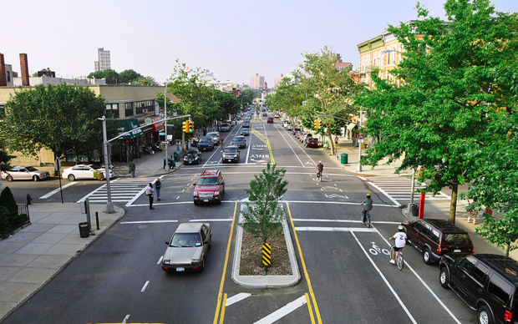
- DESIGN GUIDANCE & FLEXIBILITY
The Choose an item. shall follow and use the latest design standards available, including but not limited to: existing design guidance from the American Association of State Highway Officials (AASHTO), state Departments of Transportation, the Institute of Transportation Engineers (ITE), the National Association of City Transportation Officials (NACTO), the Americans with Disabilities Act (ADA), and the Public Right-of-Way Accessibility Guidelines (PROWAG).
The Choose an item. shall maximize design flexibility and innovation for balanced user and modal needs in our community. This includes a shift toward designing at the human scale for the needs and comfort of pedestrians. Design criteria shall not be purely prescriptive but shall be based on the thoughtful application of engineering, architectural, urban and rural design principles.
- LAND USE & CONTEXT SENSITIVITY
The Choose an item. shall implement Complete Streets solutions in a manner that is sensitive to the local context and character, aligns transportation and land use goals recorded in the Choose an item. Comprehensive Plan, and recognizes that the needs of users may vary by case, community or corridor.
- PROJECT SELECTION CRITERIA
The Choose an item. shall follow accepted or adopted design standards, including but not limited to, existing design guidance from:
- Active Transportation Alliance (ATA)
- State Department of Transportation
- Americans with Disabilities Act (ADA)
- Public Right-of-Way Accessibility Guidance (PROWAG)
- American Association of State Highway and Transportation Officials
  - Guide for Planning, Design, and Operation of Pedestrian Facilities
  - Guide for the Development of Bicycle Facilities
- National Association of City Transportation Officials – Urban Bikeway Design Guide
- The Access Board – Pedestrian Rights-of-Way Accessibility Guidelines

- IMPLEMENTATION
The Choose an item. shall view Complete Streets as integral to everyday transportation decision-making practices and processes. Toward this end, this policy shall be implemented through the following directives:
- Revisions. The Choose an item. and other relevant department, agencies, or committees will incorporate Complete Streets principles into all new projects and improvements. It will consider this policy when designing new roads or facilities.
- Inventory. The Choose an item. will maintain a comprehensive inventory of the pedestrian and bicycling infrastructure and will prioritize projects to eliminate gaps in these networks.
- Funding. Choose an item. staff will actively seek sources of funding to implement Complete Streets.
- Coordination. The Choose an item. shall continue to utilize inter-departmental project coordination to promote the better use of fiscal resources for activities that occur within the public right-of-way.
- Education. Every Complete Streets project shall include an educational component to ensure that all users understand and can safely utilize the Complete Street.
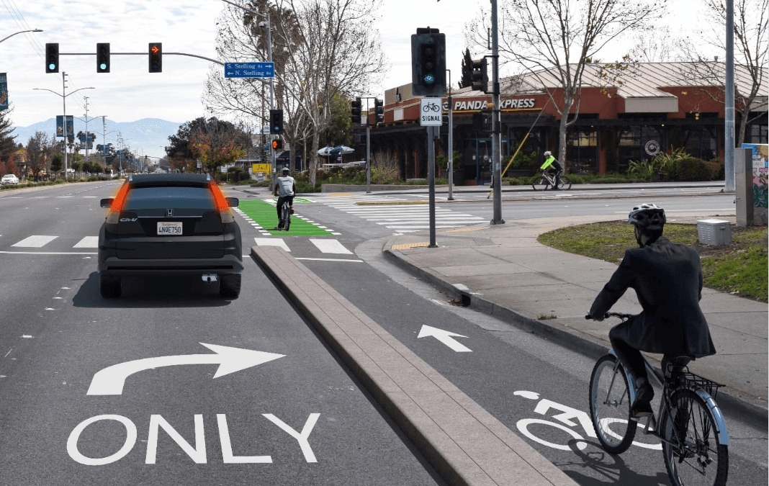
The implementation of Complete Streets shall begin through the consideration of the following identified projects and initiatives that will be considered starting points:
- Incorporate Policy into the City Comprehensive Plan (if applicable)
- Work on connection to and between trails, including improved signage
Separated bike facilities ensure safety for drivers and cyclists, like this bike lane above.
- Seek funding support through all Federal, State, and local sources
- Ensure that all bridge projects include sufficient pedestrian and bicycle accommodations
- Ensure consistency in street projects to create broader community benefits
- Preserve and further maximize on-street parking for both convenience and commerce
- Build intersections right the first time, with a vision for the present and future, and correct existing issues whenever possible
- Work with the School District to develop a Safe Routes to School program
- Pursue certification as a walk-friendly or bicycle-friendly City

